1

PROJECT REPORT

TEAM NAME: A.I.C.A
TEAM LEADER: Ambuj Mishra

Members:
Ameen S
Steve Sunny Subhash
Eldo John Giby

Deployed Link : https://triage-production-9233.up.railway.app/
1. Introduction
The COVID-19 pandemic exposed deep structural weaknesses in emergency healthcare systems worldwide. Hospitals did not fail due to lack of medical expertise or effort, but due to the absence of real-time intelligence, predictive capacity, and coordinated decision-making infrastructure. Emergency departments were overwhelmed by sudden patient surges, manual triage bottlenecks, delayed escalation, and inefficient allocation of beds and staff—leading directly to avoidable loss of life.
TRIAGE, developed by Team A.I.C.A, is a HealthTech solution designed to address these systemic challenges. It is a production-ready, AI-assisted emergency triage and surge intelligence system that augments clinical decision-making while remaining firmly grounded in globally accepted medical standards. Rather than replacing clinicians, TRIAGE empowers them with timely, explainable, and actionable intelligence during high-pressure scenarios.

2. Objectives
The key objectives of TRIAGE are:
- To assist clinicians with faster and safer triage decisions during high-load situations
- To predict emergency department surges before capacity is exceeded
- To improve system-level visibility for hospital administrators and authorities
- To ensure adherence to established clinical standards and patient safety protocols
- To deliver a scalable, reliable, and deployable HealthTech solution

3. Problem Statement
Modern emergency care systems face three persistent challenges:
- Unpredictable Patient Surges caused by pandemics, disasters, and mass-casualty events
- Manual and Reactive Triage, increasing the risk of delayed recognition of patient deterioration
- Lack of System-Level Visibility, preventing coordinated responses across hospitals
During COVID-19, many hospitals recognized overload only after ICU beds were exhausted and staff were overextended. Existing systems were reactive rather than predictive, offering little opportunity for preventive intervention.

4. Solution Overview
TRIAGE addresses these challenges through a unified, real-time platform operating at two levels:
- Hospital-Level Intelligence:
Live patient queues, vitals capture, AI-assisted risk scoring, clinician handoffs, and continuous monitoring.
- City / Authority-Level Intelligence:
Cross-hospital dashboards providing surge forecasting, alerts, and operational recommendations.
The system is fully deployed, not a conceptual prototype, and is engineered with reliability, scalability, and clinical safety as first-class requirements.

5. Clinical Standards & Safety Compliance
Clinical safety is foundational to TRIAGE. The system strictly adheres to established medical protocols, including:
- Emergency Severity Index (ESI) for patient prioritization
- START triage principles for mass-casualty and surge scenarios
- WHO-defined thresholds for vital signs and deterioration indicators
Artificial intelligence is used only to augment these standards, providing early warnings and risk probabilities while ensuring that final clinical judgment always remains with healthcare professionals. The system emphasizes explainability and avoids black-box decision-making.

6. System Architecture
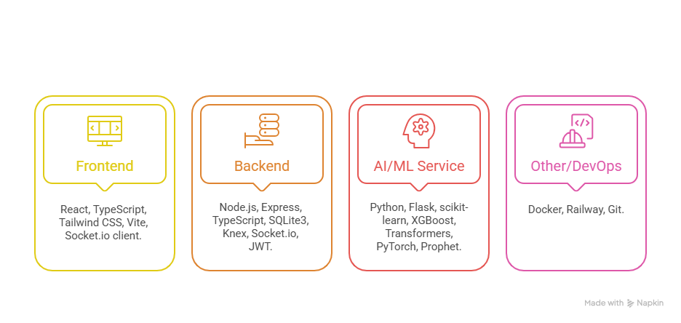
TRIAGE follows a modular, production-grade architecture:
- Frontend:
React-based dashboards for clinicians and authorities with real-time updates and intuitive visualizations
- Backend:
Express.js REST APIs with WebSocket support for live synchronization and role-based access control
- AI / ML Services:
Flask-based services for patient deterioration prediction, surge forecasting, and clinical NLP extraction
- Database:
Relational database (Sqllite-3) ensuring data integrity, auditability, and reproducible demonstrations
The system includes health checks and graceful fallback to rule-based logic when AI services are unavailable

6.1 Workflows

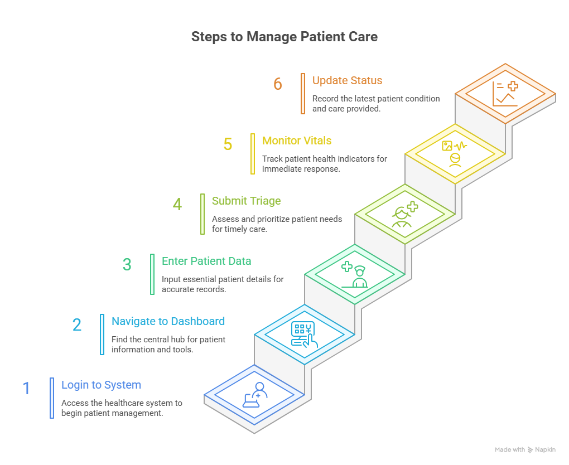

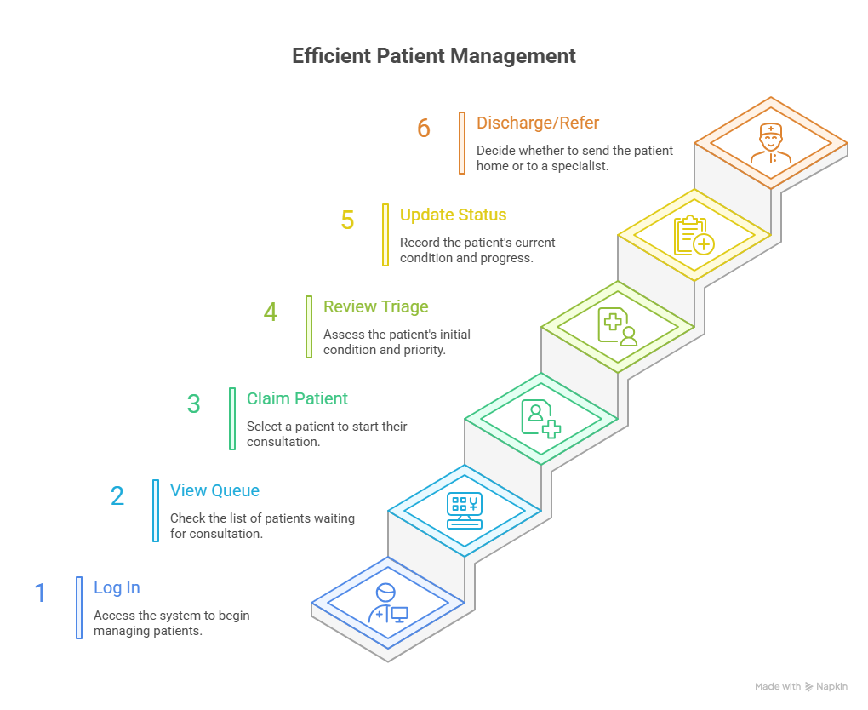
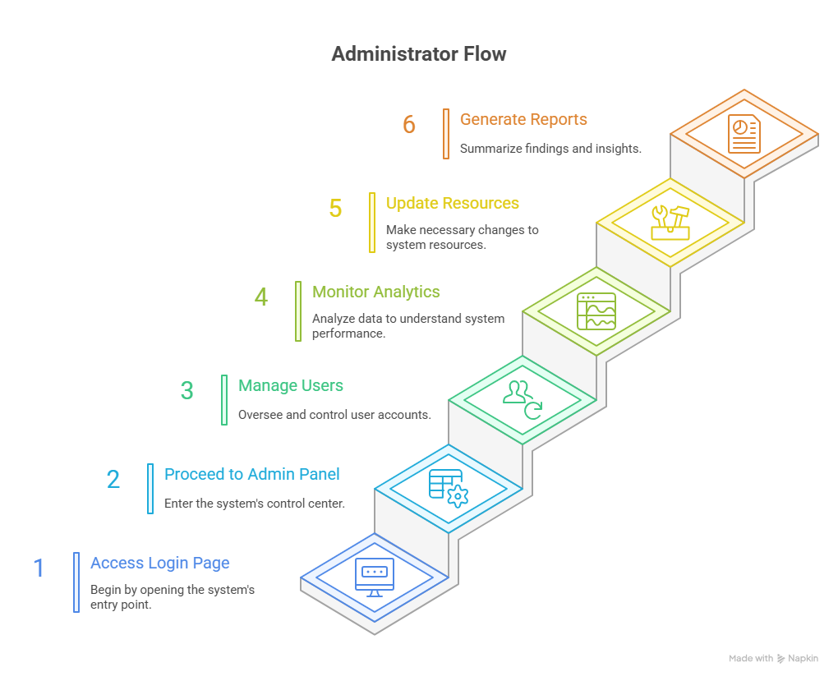
7. Methodology
The project was developed using a structured and iterative approach:
- Requirement analysis based on real emergency care challenges
- System and workflow design aligned with clinical standards
- Modular development enabling independent testing of components
- Integration of AI services with rule-based safeguards
- End-to-end testing under simulated surge conditions
This approach ensured rapid development without compromising safety or reliability.

8. Predictive Surge Intelligence
A core innovation of TRIAGE is its ability to anticipate overload before it occurs. By combining historical arrival patterns with real-time queue data, the system generates 6-hour surge forecasts, including:
- Peak load identification
- Surge threshold detection
- Confidence intervals
- Automated operational recommendations (staff reallocation, bed preparation, patient diversion)
This predictive capability directly addresses failures observed during COVID-19, where lack of early warning led to cascading breakdowns in care delivery.

9. Implementation Details
- Frontend: React-based UI for rapid data entry and situational awareness
- Backend: Express.js handling business logic and data orchestration
- AI Services: Python-based models for risk scoring and forecasting
- Security: Role-based access control and audit-ready data handling
- Deployment: Modular services designed for scalable cloud deployment

10. Testing and Validation
The system underwent:
- Unit testing for individual modules
- Integration testing across frontend, backend, and AI services
- Scenario-based testing simulating patient surges
- Validation against clinical standards to ensure safety compliance
Results confirmed stability, accuracy, and real-time performance.

11. Results and Impact Analysis
TRIAGE demonstrated:
- Reduced time-to-treatment for high-risk patients
- Earlier detection of patient deterioration
- Improved utilization of staff and beds during peak hours
- Reduced operational chaos and clinician burnout
Because it is grounded in globally accepted medical standards, TRIAGE is adaptable across hospitals, regions, and countries.

12. Challenges Faced
- Ensuring clinical safety while integrating AI
- Handling real-time synchronization under load
- Balancing predictive intelligence with explainability
- Delivering a deployable system within hackathon timelines
These challenges were addressed through careful design choices and prioritization.

13. Conclusion
COVID-19 demonstrated that emergency healthcare systems require better intelligence, not just greater effort. Developed by Team A.I.C.A under the HealthTech theme, TRIAGE delivers a deployed, standards-compliant, AI-assisted platform that enhances triage accuracy, predicts surges, and enables timely intervention.
TRIAGE transforms emergency response from reactive chaos into coordinated, intelligence-driven care—ensuring that when every second matters, decisions are guided by insight rather than panic.

14. Future Work
- Expansion to multi-city and national health systems
- Integration with hospital information systems (HIS)
- Advanced epidemiological modeling
- Mobile clinician interfaces
- Continuous validation with real clinical data

